**Lesson 8 Demo 1**

**Create a Kubernetes Cluster Using AKS**



**Steps to be followed:**

1. Setting up the prerequisites for configuring an AKS cluster
2. Creating a Kubernetes cluster using AKS service

**Step** **1:** **Setting up the prerequisites for configuring an AKS cluster**

1. Navigate to the Azure Portal home screen and click on the **Subscriptions** tab

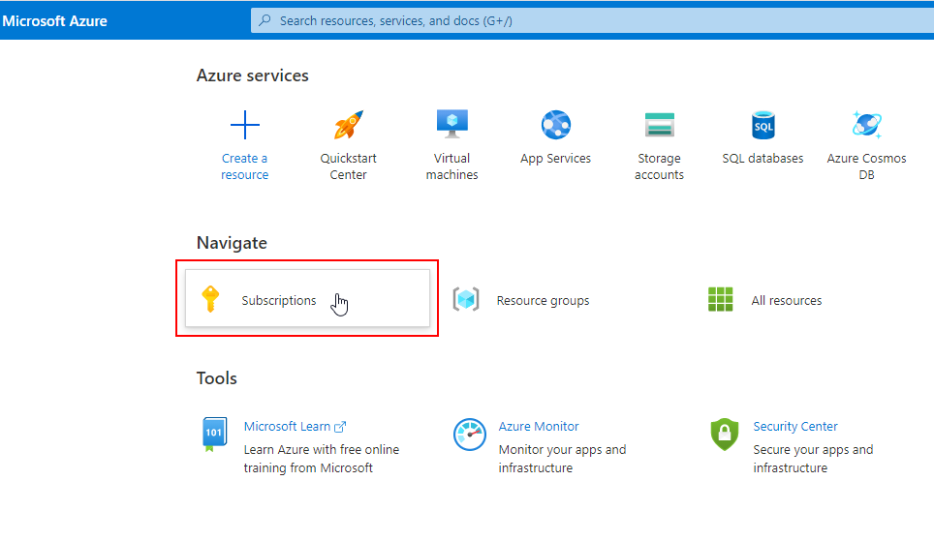

1. On Subscriptions page, click on **Vocareum-SL-20** under **Subscription name**

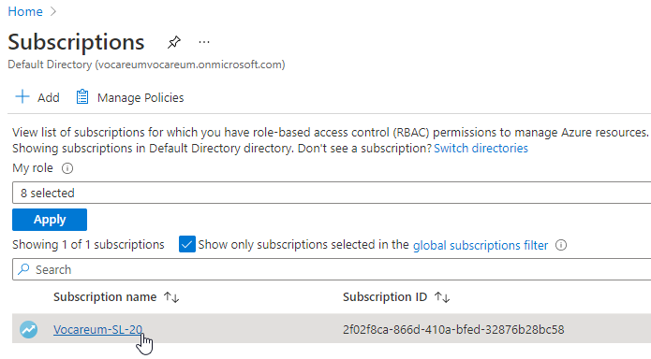

1. Inside the Vocareum-SL-20 subscription, click on the **Resource groups** under **Settings**

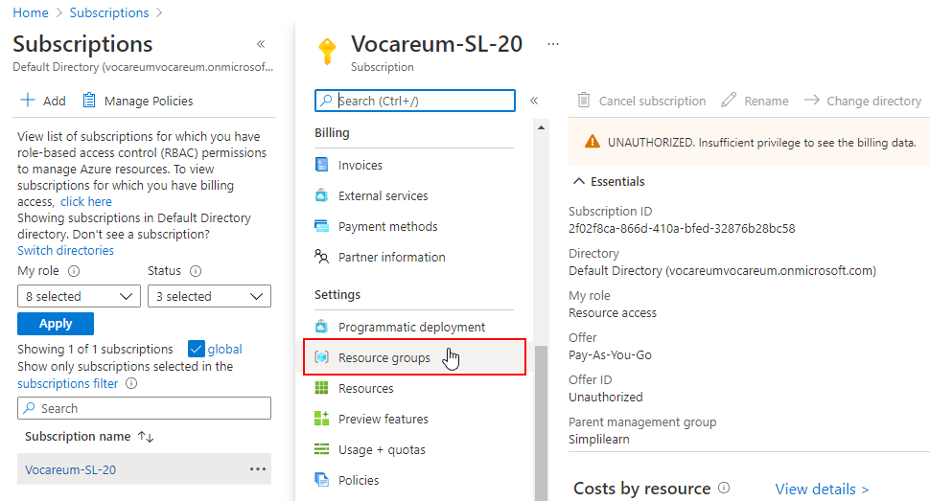

1. On the Resource groups page, click on the resource group name to navigate inside the resource group

| **Note:** Notice that the resource group name will be different for everyone, but the Subscription name will be same i.e. Vocareum-SL-20. |
| --- |

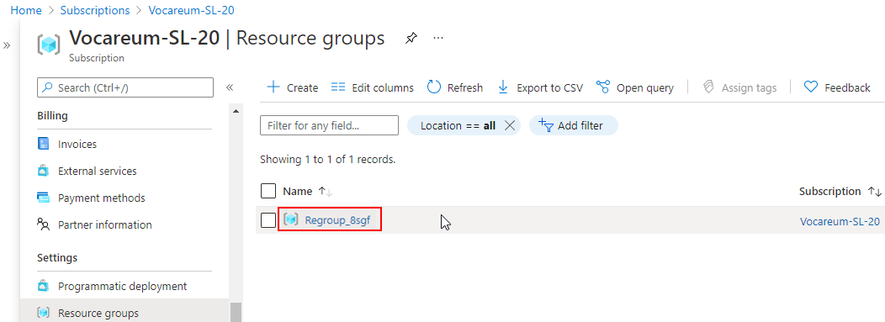

1. Inside the resource group, click on the **Create** button and select **Marketplace**

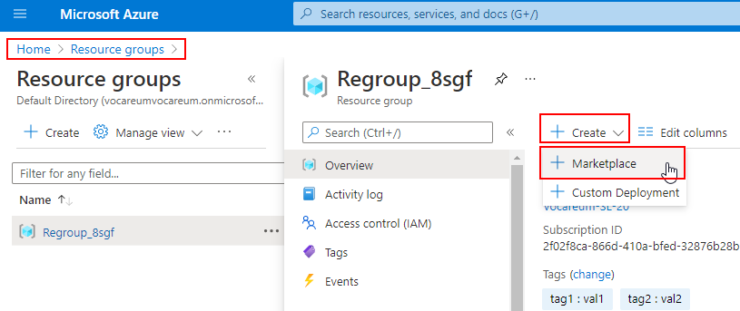

1. In the search box type **log analytics workspace** and select the **Log Analytics Workspace** resource from the dropdown

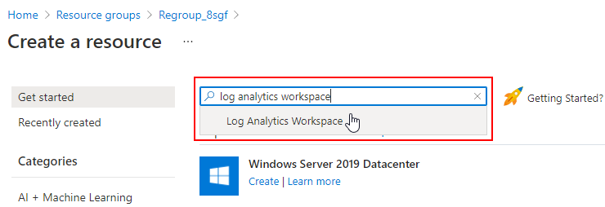

1. On Log Analytics Workspace page, click on the **Create** button to create this resource

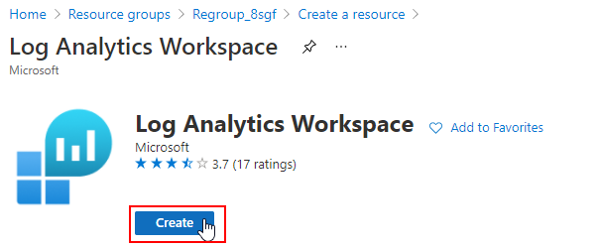

1. On the Create Log Analytics workspace page, enter the following details and click on the **Review + Create** button:

**Name:** **ContainerLogAnalytics**

**Region: West US**

| **Note:** Keep the default value for other fields. |
| --- |

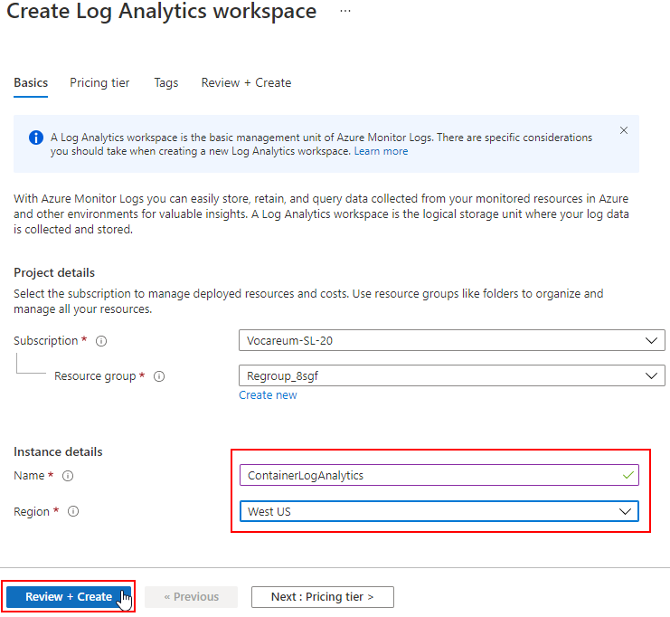

1. Once the validation is complete, click on the **Create** button

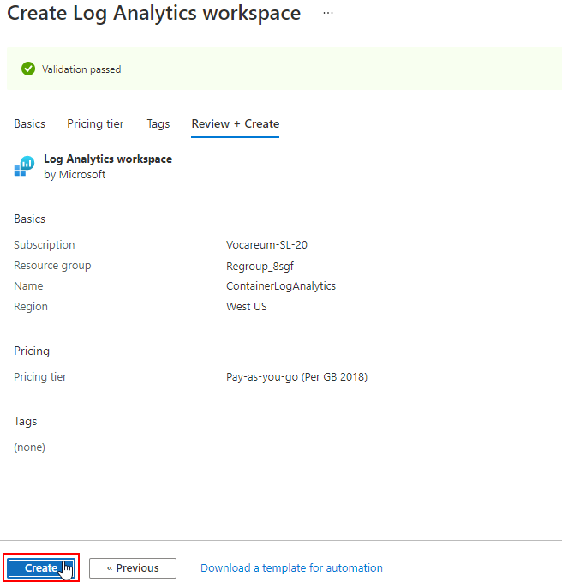

1.10 Check the newly created resource on the **Resource group** page

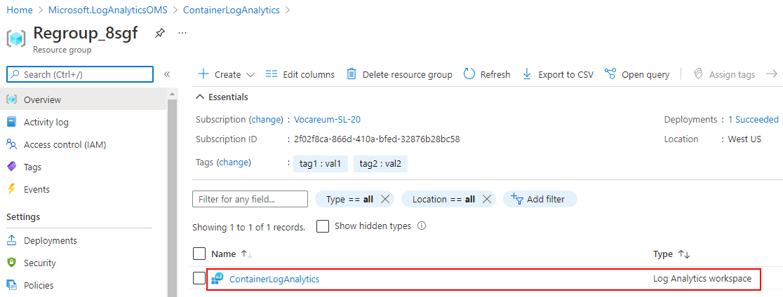

**Step 2: Creating a Kubernetes cluster using AKS service**

1. On Create a resource page, search for **Kubernetes Service** and select the **Kubernetes Service** resource from the dropdown

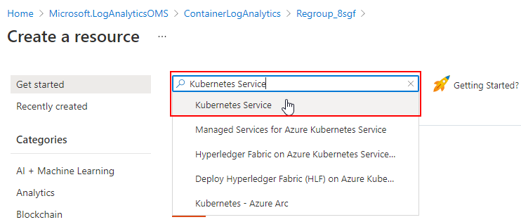

1. On Kubernetes Service page, click on the **Create** button to create this resource

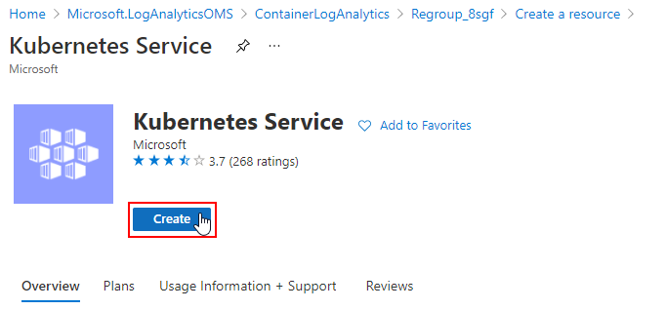

1. On Create Kubernetes Service page, enter the following details under the **Basics** tab and click on the **Integrations** tab:

**Kubernetes cluster name:** **SL-Container**

| **Note:** Keep the default value for all the other fields. Also, make sure the **Region** is set as **West US** as all the resources should be in the same region. |
| --- |

| **Note:** AKS does not support Kubernetes 1.20 version yet. |
| --- |

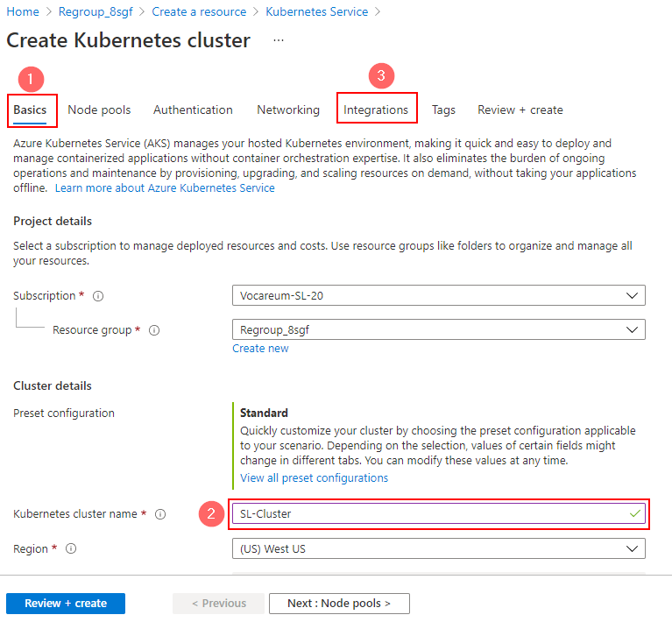

1. On the Integrations tab, select the **Enabled** option for **Continuous monitoring** and make sure the **Log Analytics workspace** is using **ContainerLogAnalytics**. Click on the **Review + Create** button

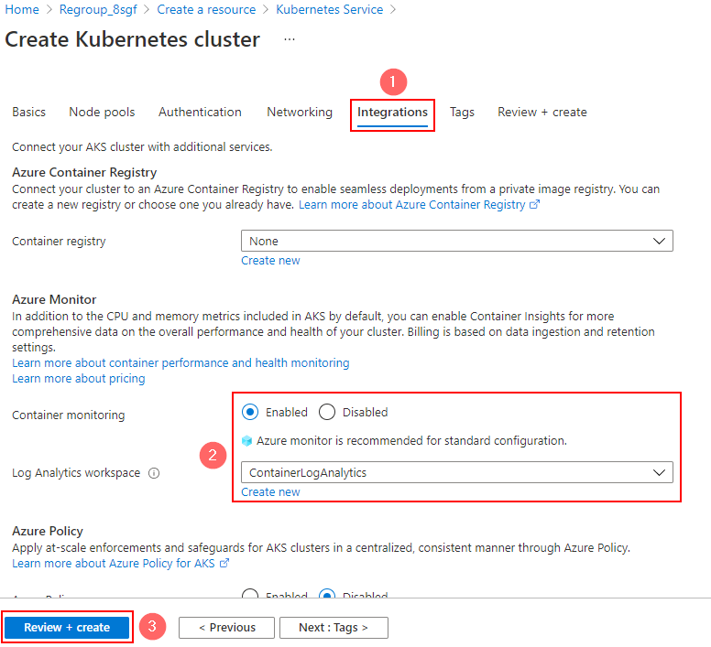

1. Once the validation is complete, click on the **Create** button

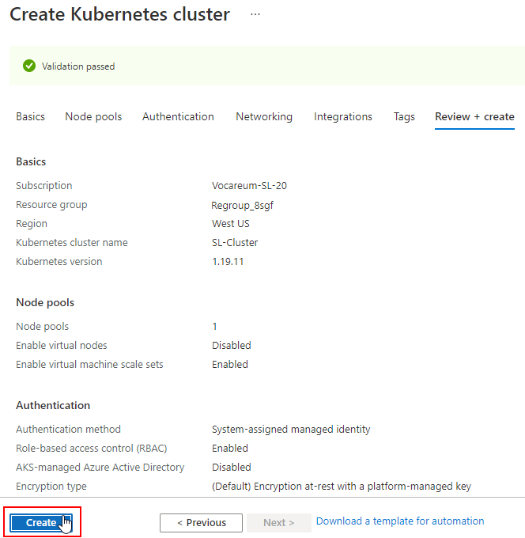

1. Check the resource on the **Resource group** page and click on the **SL-Cluster** resource

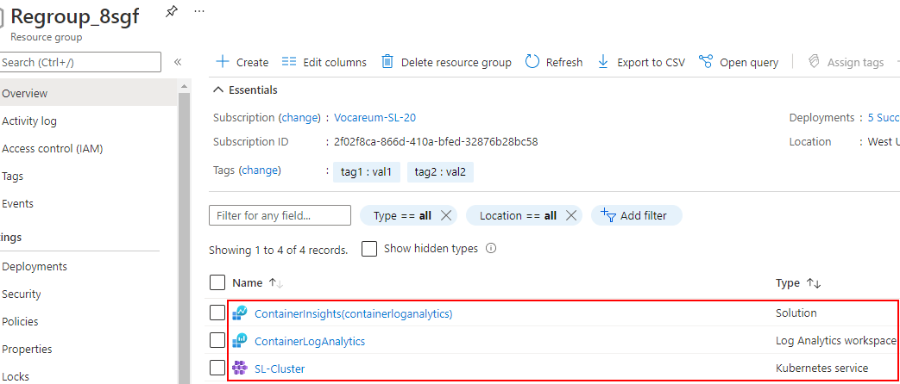

1. Click on Node Pool from left-side panel and check the Node pool and Nodes tab to verify the nodes in the cluster

